**Cross Shelf Patterns – Physical Oceanography**

During the sampling period, the East Australian Current (EAC) flowed coherently along the coast before separating from the coast between 31 and 32 S where it formed a large anticyclonic eddy. The three northern most sites had increasing velocity over previous month and all crossed from cool inshore waters into warm (21 °C) EAC water. This is contrasted by the Diamond Head transect which was located south of the separation zone in cooler (<19.5 °C) waters and did not cross into EAC waters. All transects showed low chlorophyll levels (<1.4 mg m-3) peaking at the surface.

All sites had low Chlorophyll a in the preceding month with negligible wind effects in the 3 days prior to the transects.

**Cape Byron**

This transect was dominated by the EAC which had a strong southward flow (1.50 m s-1) centred over the 200 m isobath (27.6 km offshore). The EAC also showed slight onshore movement which increased offshore and with depth (up to 0.26 m s-1).

There was strong current driven uplift of the isotherms inshore of the EAC with the 21 °C isotherm rising to the surface from 70 m depth over 5 km and the 20 °C isotherm rising to the surface from 100m depth over 15 km.

**Evans Head**

This transect was dominated by the EAC which had a strong southward flow (1.47 m s-1) centred 36.1 km offshore (220 m bathymetry). The EAC had a slight offshore movement (0.27 m s-1) which increased with distance offshore.

There was strong current driven uplift of the isotherms inshore of the EAC with the 21 °C isotherm rising to the surface from 70m depth over 6 km and the 20 °C isotherm rising to the surface from 100m depth over 15 km.

**North Solitary**

This transect was dominated by the EAC which had a strong southward flow (1.59 m s-1) centred 37.7 km offshore (310 m bathymetry). The EAC showed slight onshore movement offshore and at depth (0.15 m s-1).

There was strong current driven uplift of the isotherms inshore of the EAC with the 21 °C isotherm rising to the surface from 70m depth over 3 km and the 20 °C isotherm rising to the surface from 100m depth over 10 km.

**Diamond Head**

The transect at this site did not cross into the EAC which had separated from the coast to the north. Within the transect the, along shore velocities are low (< 0.43 m s-1) with corresponding low onshore movement of water (0.11 m s-1) in the surface waters with offshore movement (0.27 m s-1) in the deeper waters.

There was minor uplift of the temperature isotherms with all isotherms rising approximately 20 – 40 m as they came onto the continental shelf.

**Biological Patterns (maybe rearrange to discuss by site rather than variable or merge with physical section)**

**Zooplankton Abundance**

All four transects showed higher abundance of zooplankton in the inner shelf region (> 10,000 individuals m-3) with abundance declining with both distance offshore and depth to less than 5,000 individuals m-3. **(NOTE I can’t figure out the units here 0.575 does not work as the maximum for log10(Abund) on Jason’s plots)**

**Zooplankton Biomass**

Biomass generally showed a similar pattern to abundance with the highest biomasses at each transect observed in the inner shelf waters (> 2 mg m-3) with general declines offshore and with depth. The Evans Head and North Solitary transects also showed elevated biomass levels (~2.25 mg m-3)at the outer edge of the continental shelf around the 21 °C isotherm. The transect at Evans Head did not show a noticeable decline in biomass with distance from the coast but this transect did not extend past the edge of the continental shelf where the declines were seen in the other 3 transects.

**Zooplankton Geometric Mean Size**

Two distinct patterns in Geometric mean size (GMS) were evident in our 4 transects. Cape Byron and Diamond had a larger GMS towards the coast (> 475 µm ESD) with the GMS declining offshore. Evans Head and North Solitary showed a small increase in GMS around the 21 °C isobar which was located near the edge of the continental shelf and offshore respectively. These sites also showed a general decline in GMS with depth.

**Zooplankton Pareto Slope**

The three northern transects showed steeper NBSS slopes in the inner shelf waters compared to the offshore EAC water. The steep slopes (< -1.3) were aligned with waters cooler than 20 °C. The southernmost site, Diamond Head, showed no cross-shelf patterning with a shallower slope (~-0.95) in all surface waters and an increase in steepness with depth (~-1.1).

Additional thoughts for discussion:

High biomass and abundance inshore of EAC combined with Steep slope and smaller particles implies a highly productive habitat in inner shelf water

* Can we show that this band of inner shelf water is persistent?
  + Maybe with the temperature gradient?

Time of day sampling, Evans Head and Cape Byron at Night (1am and 11pm respectively) while North Solitary and Diamond Head During the day (1pm and 11am, assuming times were AEST)

Figure X. Map of eastern Australia showing the 4 transect sites and warm southward flowing East Australian Current. The SST and velocity vectors are from XXXX on the 6th September 2004.

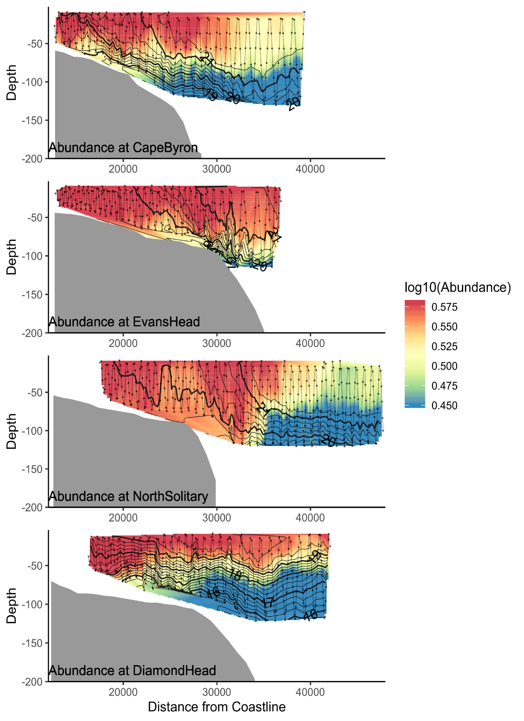

Figure X. Cross shelf distribution of zooplankton abundance overlaid with temperature contours.

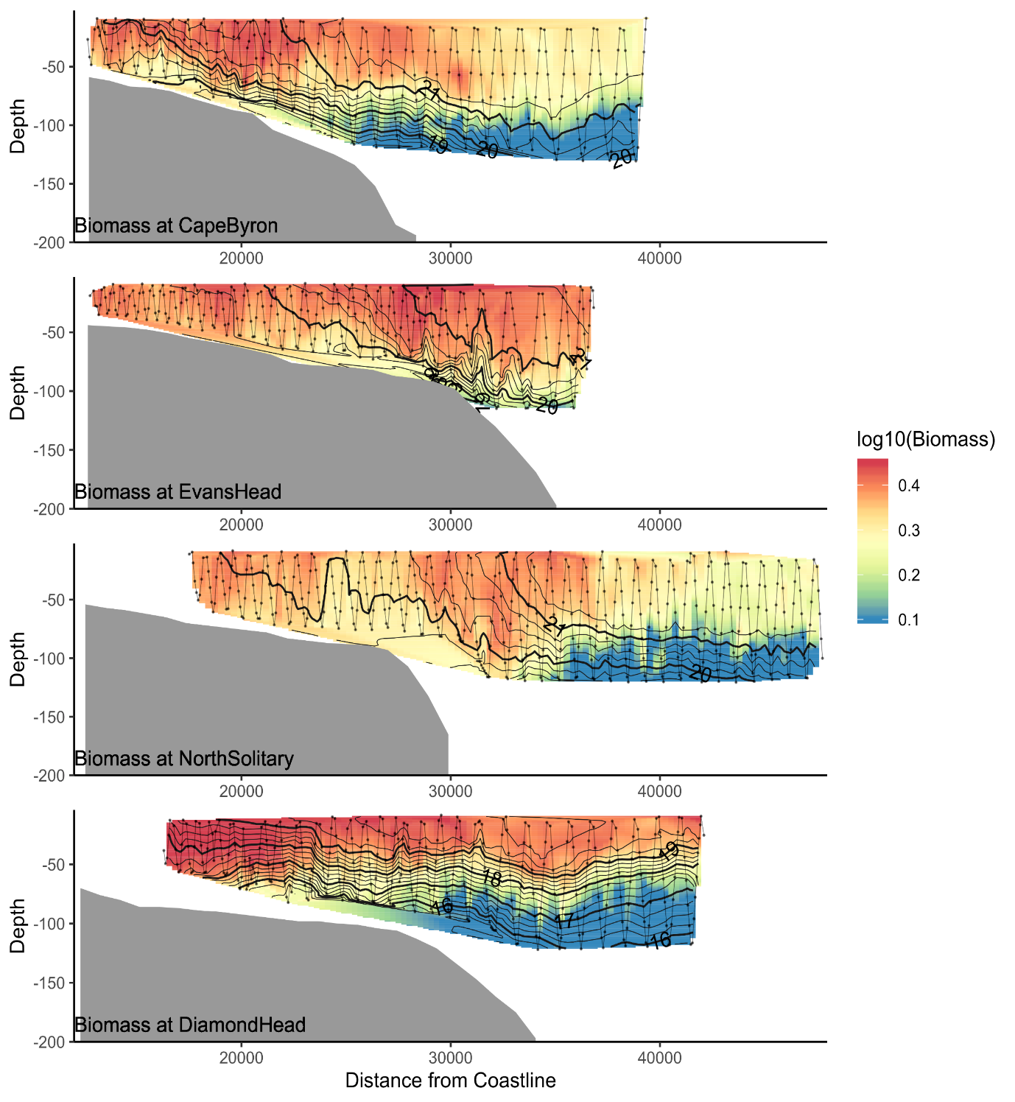

Figure X. Cross shelf distribution of zooplankton biomass overlaid with temperature contours.

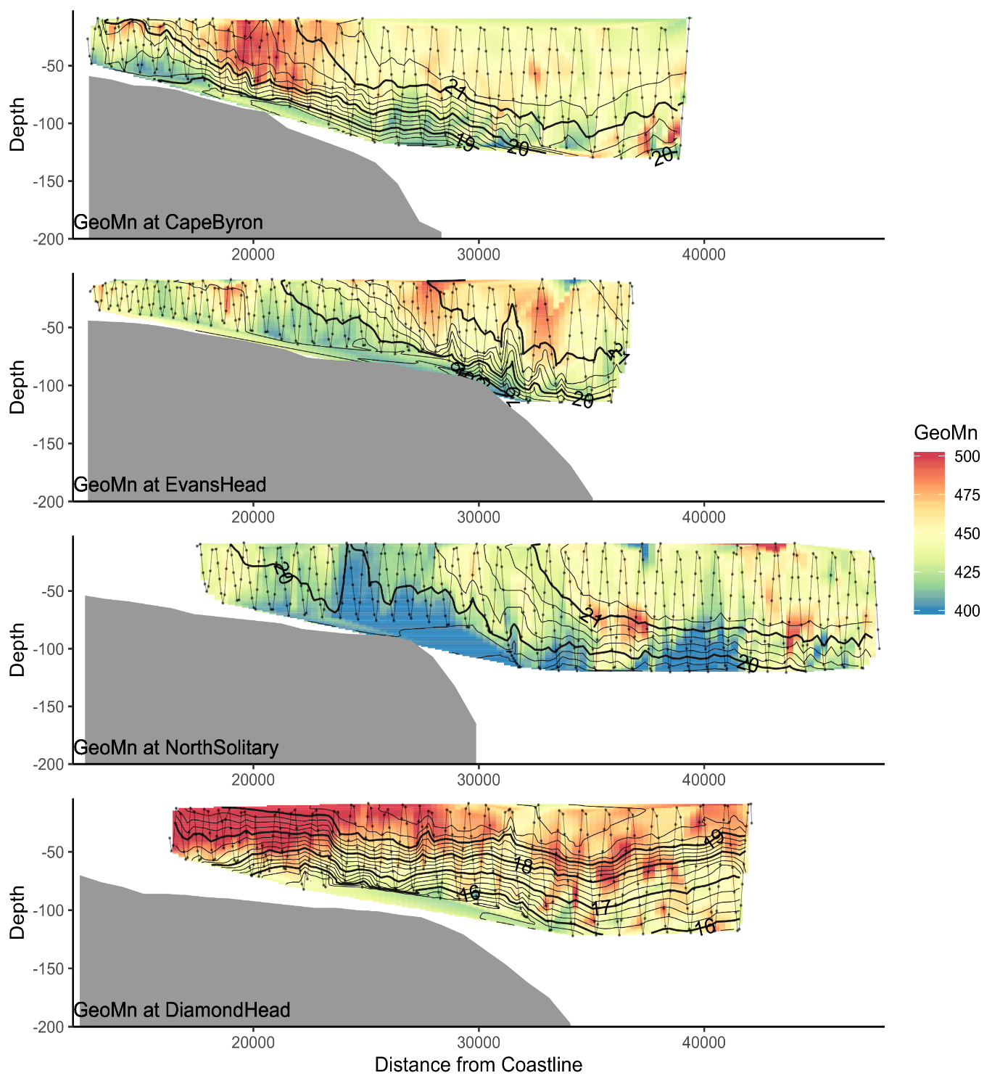

Figure X. Cross shelf distribution of zooplankton geometric mean size (GeoMn) overlaid with temperature contours.

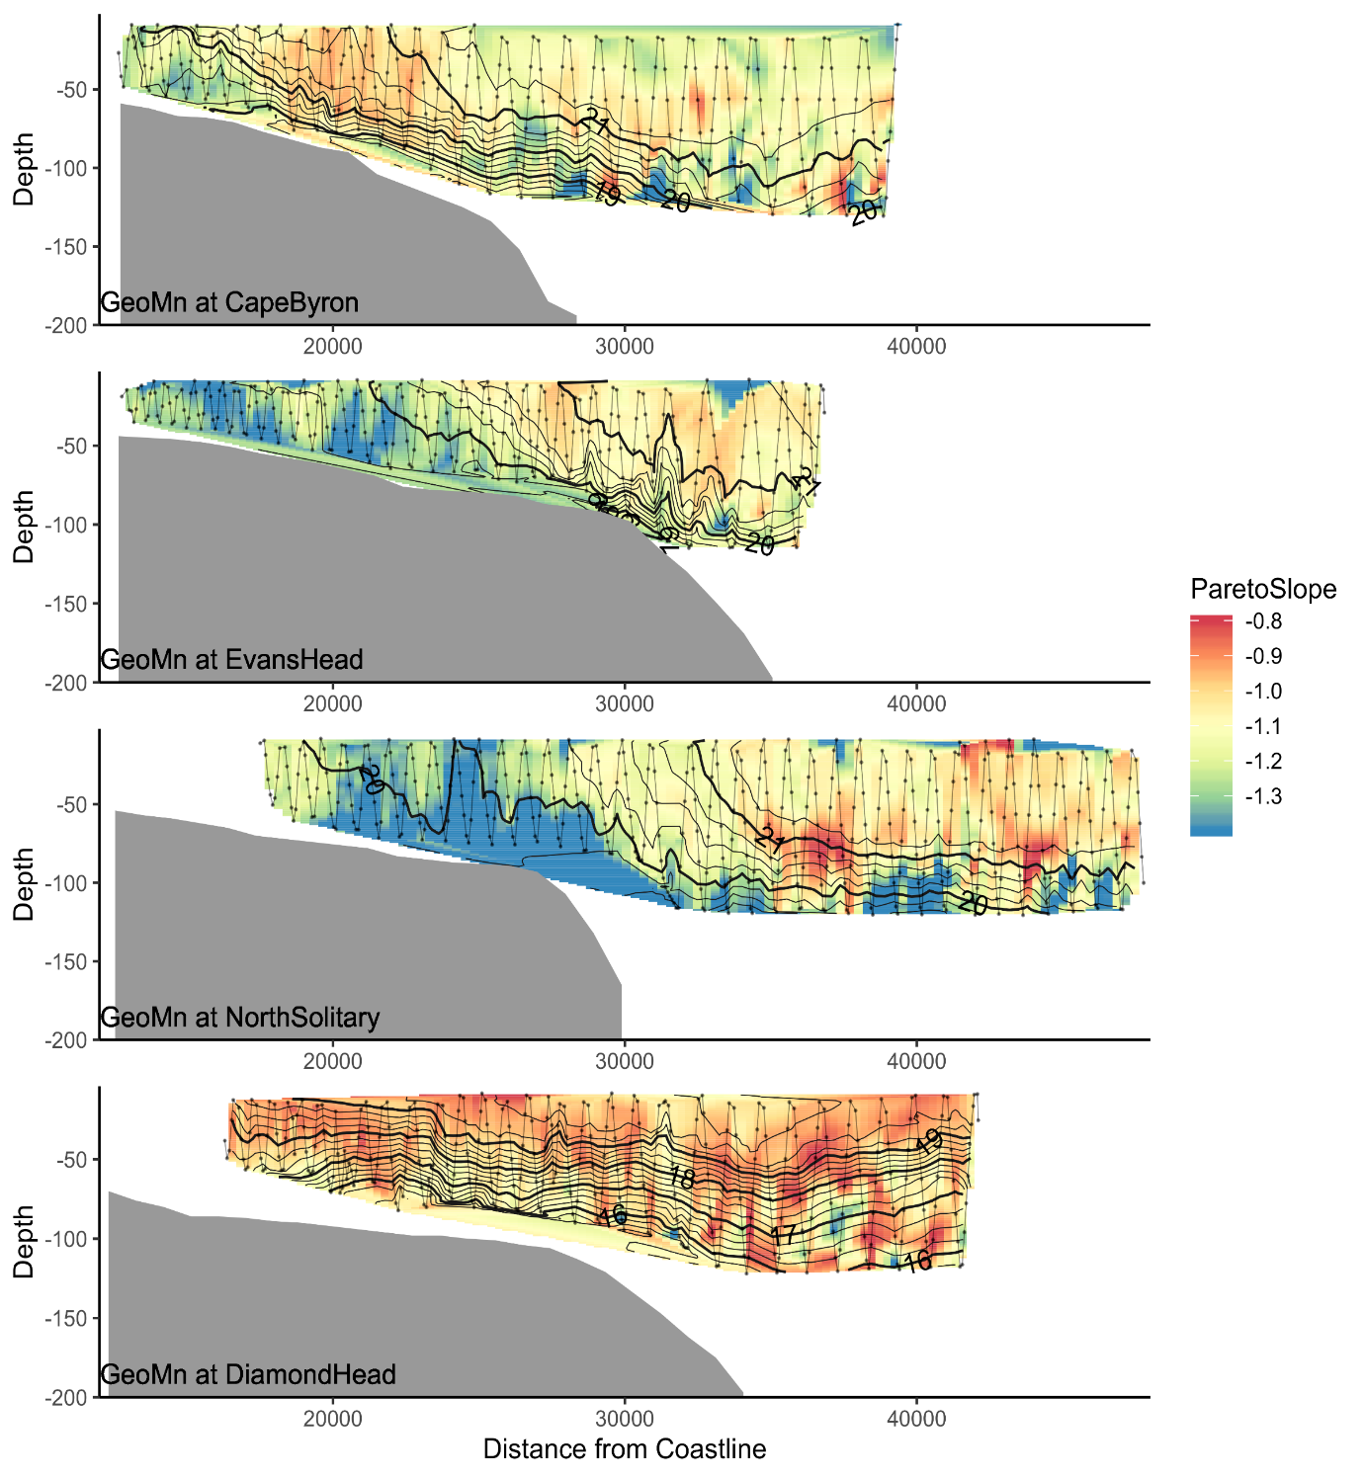

Figure X. Cross shelf distribution of zooplankton NBSS pareto slope overlaid with temperature contours.